LOGISTICS DATA ANALYST INTERNSHIP

WEEK 3 REPORT
Advanced Data Analysis and Visualization in Logistics

Prepared by: [S.R. Reshmi]
Dataset: Hypothetical practice dataset

1. Abstract
This report demonstrates exploratory data analysis (EDA) and visualization for a hypothetical logistics operation. A dataset of 24 shipments is analyzed using Python, Pandas, and Matplotlib. The variables include shipment volume, delivery time, transportation cost, delay days, delivery status, transport mode, and region. Descriptive statistics, group comparisons, and correlations are calculated, and six charts are used to interpret patterns. The data is illustrative and does not represent actual company records.

2. Introduction and Objectives
Logistics teams need clear information to manage delivery time, transport costs, and service reliability. EDA helps summarize raw data, detect patterns, and identify questions that require further investigation. The objectives are to inspect a simulated dataset, calculate central tendencies and distributions, compare transport modes and regions, study relationships between numeric variables, create visualizations, and suggest practical improvements.

3. Hypothetical Dataset
Each row represents one shipment. The 24 records are created only for learning purposes. Shipment_ID is the unique identifier; Region identifies North, South, East, or West; Transport_Mode is Road, Rail, or Air; Shipment_Volume_kg records shipment weight; Delivery_Time_days records elapsed delivery time; Transport_Cost_USD records illustrative cost; Delay_Days records delay duration; and Delivery_Status is On Time or Delayed.
Variable | Description | Type
Shipment_ID | Unique shipment reference | Integer
Region | Delivery region | Category
Transport_Mode | Road, Rail, or Air | Category
Shipment_Volume_kg | Shipment weight in kilograms | Numeric
Delivery_Time_days | Delivery time in days | Numeric
Transport_Cost_USD | Illustrative transportation cost | Numeric
Delay_Days | Number of delay days | Integer
Delivery_Status | On Time or Delayed | Category

4. Methodology and Tools
The dataset is loaded into a Pandas DataFrame. The script inspects the first records, calculates descriptive statistics, counts delivery statuses, compares average cost and delivery time by categories, calculates a correlation matrix, and creates six charts using Matplotlib. A histogram is used for a distribution, bar charts compare categories, a scatter plot examines two numeric variables, and a heatmap summarizes correlations.

5. Exploratory Data Analysis

5.1 Descriptive Statistics
Variable | Mean | Median | Std. Dev. | Min | Max
Shipment_Volume_kg | 177.71 | 157.50 | 78.73 | 85.00 | 340.00
Delivery_Time_days | 2.18 | 2.35 | 0.87 | 0.70 | 3.50
Transport_Cost_USD | 19.92 | 20.50 | 7.43 | 8.00 | 32.00
Delay_Days | 2.04 | 2.00 | 1.52 | 0.00 | 5.00
The average delivery time is 2.18 days and the median is 2.35 days. Average transportation cost is $19.92. In this sample, 15 shipments are on time (62.5%) and 9 are delayed (37.5%). These results describe only the hypothetical sample, not industry performance.

5.2 Delivery-Time Distribution
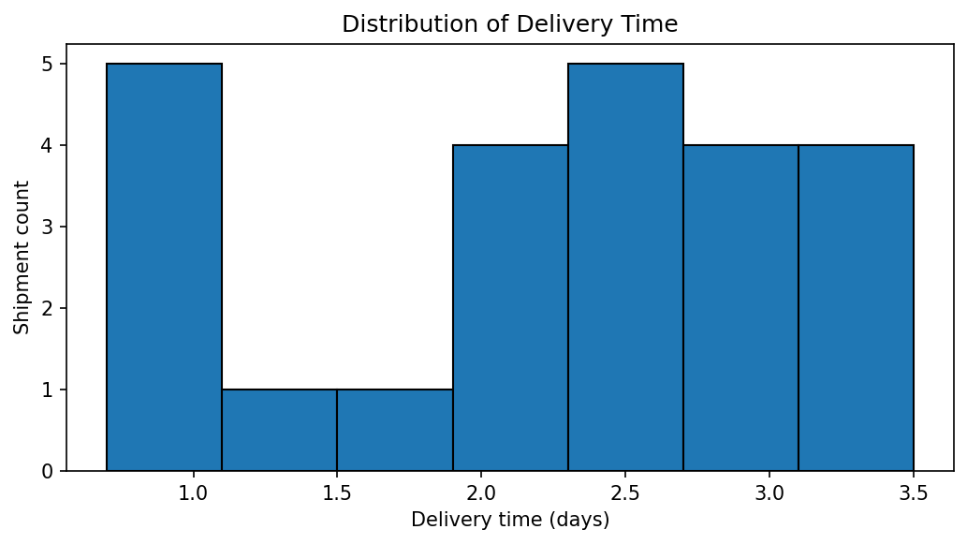
Why this chart: A histogram groups delivery times into intervals and shows where most shipments fall. Interpretation: delivery time varies across the sample; therefore, the average alone may hide slower shipments. A real analyst should investigate unusually long delivery times.

5.3 Average Cost by Transport Mode
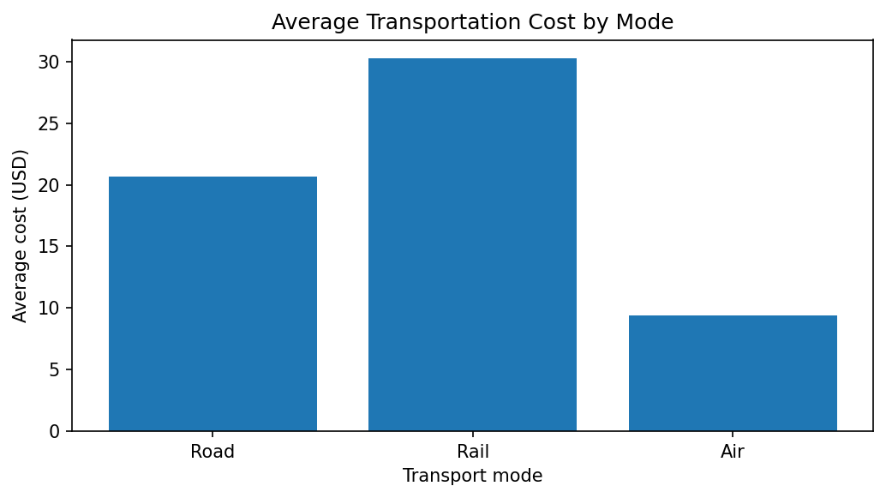
Why this chart: A bar chart makes category averages easy to compare. Interpretation: air shipments have higher average costs in this sample, while road shipments are cheaper on average. Mode selection should also consider urgency, distance, cargo type, and service requirements.

5.4 Delivery Time vs Transportation Cost
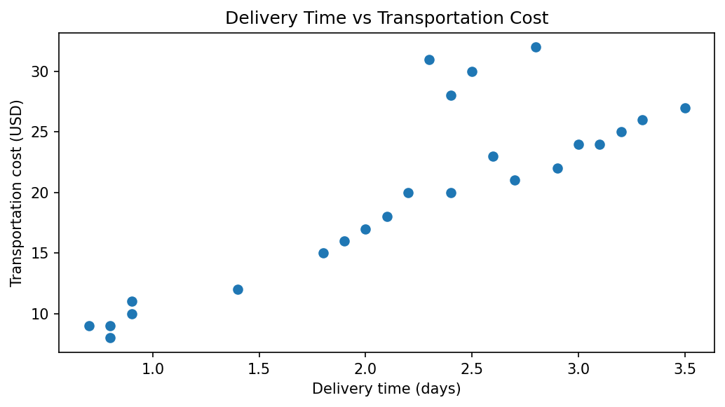
Why this chart: A scatter plot shows individual shipments and helps inspect relationships between two numeric variables. The Pearson correlation between delivery time and cost is 0.86. Interpretation: costs and times vary by transport mode. Correlation does not prove causation; transport mode and shipment characteristics may affect both.

5.5 On-Time and Delayed Shipments
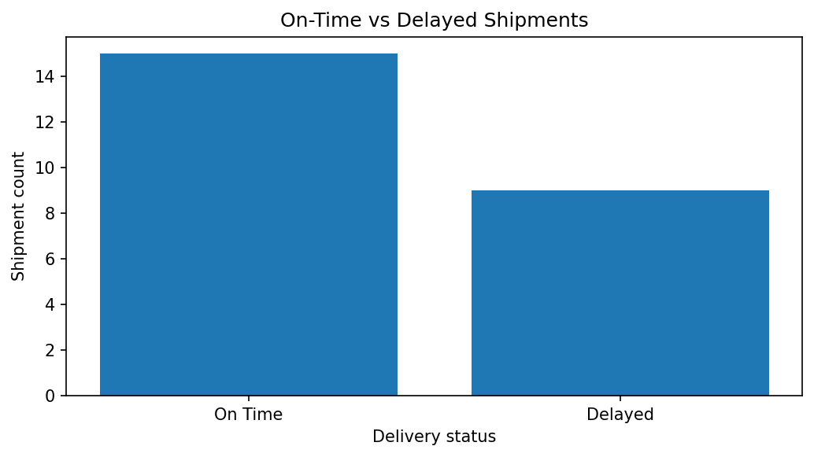
Why this chart: A bar chart compares the count of each status. Interpretation: 9 out of 24 shipments are marked delayed. A logistics team should review these records for repeated routes, dispatch issues, or other possible delay factors.

5.6 Correlation Heatmap
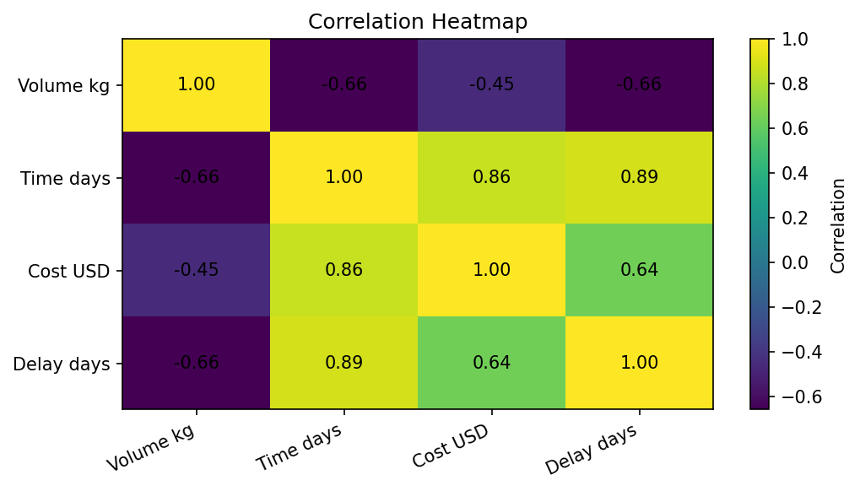
Why this chart: A heatmap summarizes the direction and strength of linear relationships. Delivery time and delay days have correlation 0.89 in this sample. Correlation is not proof of cause, and the small hypothetical dataset limits generalization.

5.7 Average Delivery Time by Region
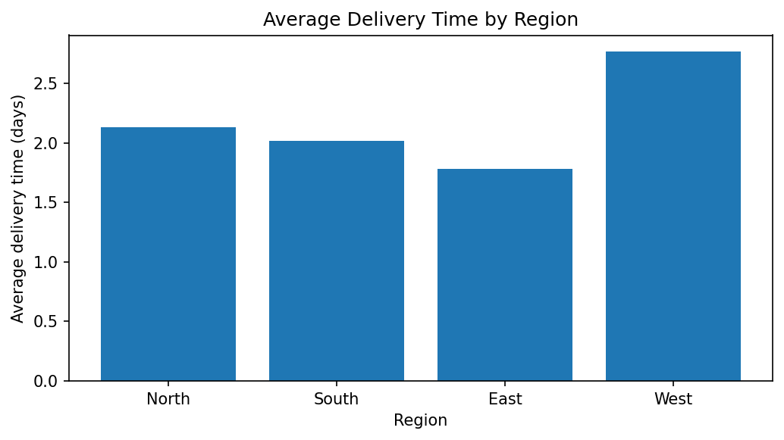
Why this chart: It compares average delivery time across regions. The West region has the highest sample average, while East has the lowest. Investigate distance, traffic, dispatch schedules, and shipment mix before attributing the difference to region.

6. Summary by Transport Mode
Mode | Shipments | Average days | Average cost | On-time rate
Air | 5 | 0.82 | $9.40 | 100.0%
Rail | 4 | 2.50 | $30.25 | 100.0%
Road | 15 | 2.54 | $20.67 | 40.0%

7. Key Insights
- The on-time rate in this sample is 62.5%; delayed shipments deserve individual review.
- Average cost differs across transport modes, showing a trade-off between speed and cost in this constructed dataset.
- The West region has the longest average delivery time in this sample and may be worth further investigation.
- Delivery-time distribution shows that variation matters in addition to the mean.
- Correlations can reveal patterns, but they cannot establish causation and may be influenced by transport mode, distance, or shipment type.

8. Recommendations
- Track on-time delivery rate regularly and compare it with a target defined by the business.
- Record planned and actual delivery times consistently to measure delays correctly.
- Collect route distance, fuel cost, traffic, weather, package type, and dispatch time to investigate causes.
- Compare modes using both service level and cost; do not choose based on cost alone.
- Review delayed shipments in regions with higher average delivery times and verify patterns using more data.
- Create a dashboard with delivery-time distribution, status counts, average cost by mode, and regional performance.
- Use a larger, real, documented dataset before making operational decisions.

9. Python Code Excerpts

Descriptive statistics
print(df[["Delivery_Time_days", "Transport_Cost_USD"]].describe())

Group comparison
print(df.groupby("Transport_Mode")["Transport_Cost_USD"].mean())

Correlation
print(df[["Shipment_Volume_kg", "Delivery_Time_days", "Transport_Cost_USD", "Delay_Days"]].corr())

Scatter plot
plt.scatter(df["Delivery_Time_days"], df["Transport_Cost_USD"])\nplt.xlabel("Delivery time (days)")\nplt.ylabel("Transportation cost (USD)")\nplt.show()
The complete runnable Python script is included as a separate file. It prints summary statistics and saves the six chart images plus the hypothetical dataset as a CSV file.

10. Limitations
The dataset contains only 24 hypothetical records. It does not represent a real company or an industry benchmark, and the visible patterns should not be generalized. The analysis is descriptive, not predictive. More data and domain context are required before making operational changes.

11. Conclusion
This task demonstrates how statistics and visualizations can turn logistics records into easier-to-understand evidence. Histograms reveal distributions, bar charts compare categories, scatter plots show possible relationships, and heatmaps summarize correlations. The sample suggests questions about delayed shipments, cost differences between transport modes, and regional delivery time. The main lesson is to interpret charts alongside context and data-quality checks. Future work should repeat this workflow on a larger real dataset.

